**Final Submission Document**

Team Name: Rasp-bear-y Pi

Technology: Quest 2 Built-in Headset Tracking

|  |  |
| --- | --- |
| Name | Anticipated Role |
| Ladarius Course | Developer/World Building |
| Tanner Hess | Developer/Tech Support |
| Collin Newton | Developer/Narrative |
| Brayden Ball | Developer/Coding |

Environment Title: Bear Training Facility

The idea is to use some interesting assets in new interactive ways. Using motion tracking we will attempt to have a bear respond objects you can interact with within the environment. Maybe the bear will do what you want or the action of giving it food will make the bear do more. Who wouldn’t want to interact with a bear without having to be near one in real life?

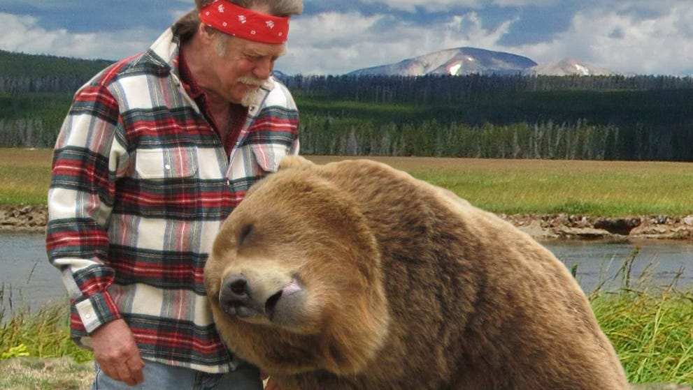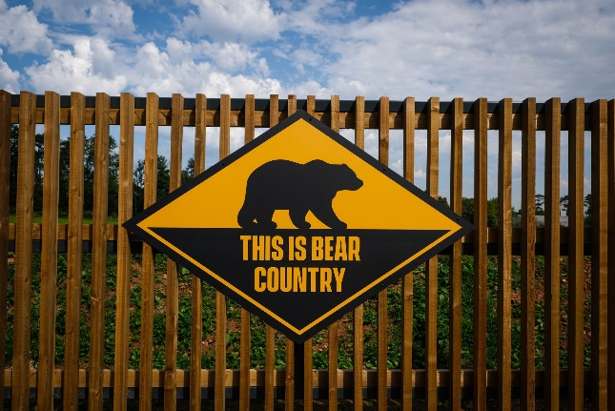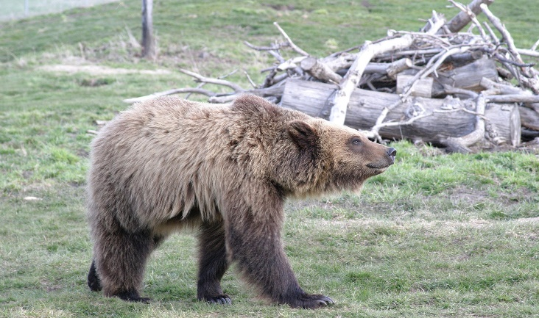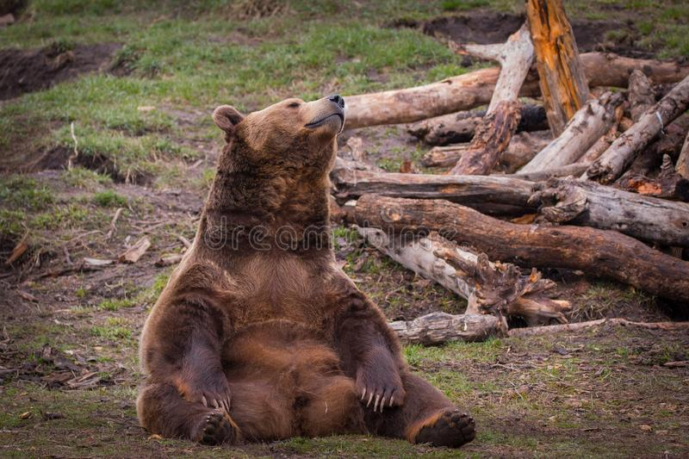

Story Board:

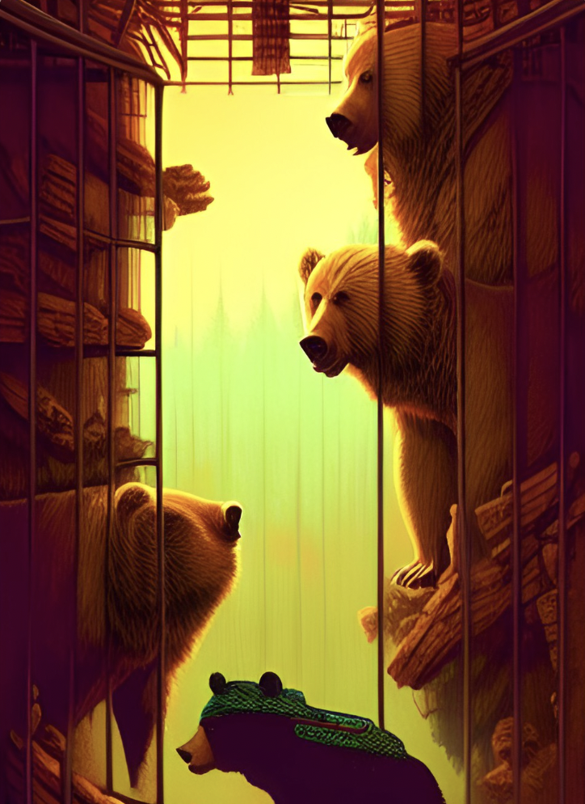

OR 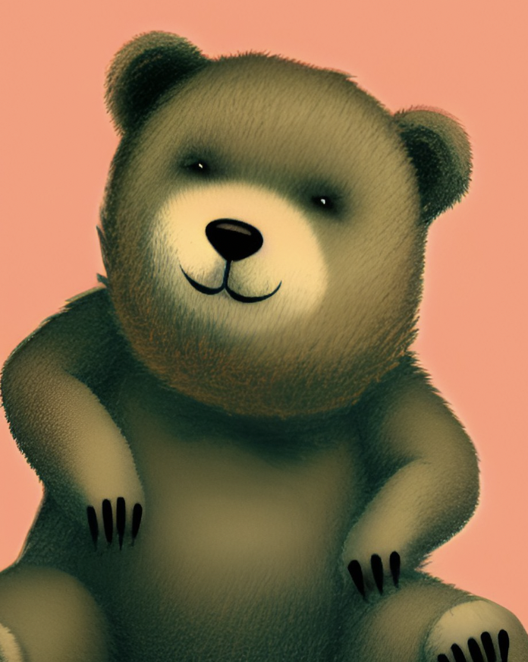

Open in a room with a bear in pit. Learn you can feed them and make them either love or hate you!

Narrative: Being a robot who has rarely seen organic life forms, when you discovered a bear in the forest you jumped at the chance to observe it. As any highly intelligent robot would do, rather than examine the bear in its own environment, you decide to take the bear back to your facility to eliminate any external variables. Now that you have the bear isolated from all aspects of nature, you begin your first experiment: to examine how the life form reacts to different food sources.